Unity Team
Matteo Dell’Oro, Alfio Giuliano Faro, Gabriel Logronio

CHARACTERS DOCUMENT

Purpose | Document giving an overview of the main characters of the game
Creation date | 05-12-2017
Current owner | Gabriel Logronio
Last modification | 07-12-2017

Revision History
Who | When | What
Logronio | 05-12-2017 | Created this document
Logronio | 07-12-2017 | Added enemies list

Regular party Characters
Clara Oswald |  | Clara was the companion of the 11th and the 12th Doctor’s reincarnations, but they have parted ways, so she is now heading back to the fixed point in time that is her death moment alongside Me. Brave and clever, she always tries to find a thoughtful way to solve problems, using as less violence as possible.  In combat she focuses in buffing and healing her allies, while debuffing the enemies, while dealing a little damage with her attacks.
Me (Ashildr) | 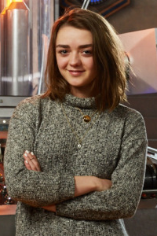 | Once a Viking, now she has become immortal due to the Mire repair kit. After a long life she has become experienced with the whole universe, getting to end of time itself. She now accompanies Clara into her journey, helping her with her abilities. After her limitless time spent she has now become cynic and cold, but she hopes that Clara’s influence can bring back in her the meaning of life.  In combat uses her experience gained in thousands of years off wars and military service, allowing her to deal huge amount of damage to any enemy with her agility.
Supporting party Characters
Alros, the Silurian thief | 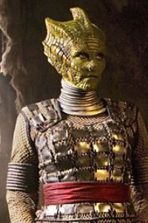 | Former slave in the cybermen factory, he manages to escape with few companions and now lives hiding in the nearby zone, hoping to find a way to save all the remaining slaves in his same old factory, included his little brother. This opportunity comes when he first meets Clara and Me.  In combat he uses the agility and the experience in fighting gained through years of fighting the cybermen, dealing burst of physical damage to single enemy or magic damage to a group of enemies.  Out of combat his high agility allows him to climb walls and jump over some obstacles.
Captain Jack Harkness | 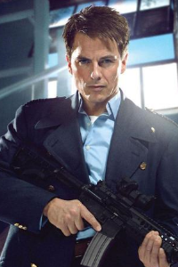 | In the past he had been companion of he 10th Doctor and then leader of the Torchwood. While roaming the Earth, gets to meet Jenny and Sam, both trying to contact the Doctor, so he joins them hoping to meet his old friend once again.  In combat his hard military training, alongside his incredible regeneration ability, allows him to tank high damage from the enemies while dealing a lot of damage to the enemies’ front-line.  Out of combat he ca use his charisma to persuade people to help him in his cause, convincing them to do what the team needs.
Jenny, the Doctor’s daughter | 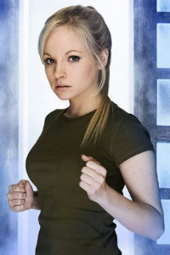 | She was created from the Doctor’s DNA, so she got called “the Doctor’s daughter”, although she was meant to be a soldier. After being left from his father, who thought her to be dead, she decides to seek the adventure when she finally meets Jack and Sam, with whom she tries to contact the Doctor. Once only a pure fighter, she now knows how to handle situations differently, keeping always her morale up.  Being created as a soldier, she has great knowledge in handling many different weapons, that she uses with her abilities to deal a lot of damage to groups of enemies.  Out of combat she can use a small device she got I her adventures to hack many different terminals and computers.
Sam Swift, the mad man | 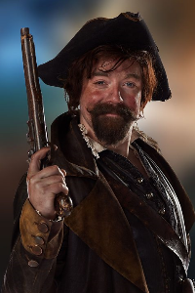 | Born in 17th century, has become immortal due to the Mire repair kit that Me and the Doctor used on him. After being connected with a parallel universe, he has gained the ability to communicate directly with the player, giving him tips and suggestions, while other characters just think that he has gone momentarily crazy. Externally he is always cheerful and loves to make jokes and puns, although after all he had gone through, outliving any person he ever loved, he had fallen in a state of interior depression, helping Clara hoping to find the Doctor and so a way to die. He has now fear of any battle, so prefers to stay in the Tardis, communicating with the team through a device.
Strax, the Sontaran soldier | 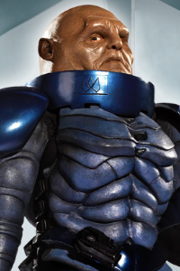 | A Sontaran soldier, he is well trained in the use of many different weapons and heavy armours. While living with the Paternoster Gang alongside his friends Madame Vastra and Jenny, he suddenly gets disappeared, leaving nothing behind allowing to trace him. As a Sontaran, the brute force is the only way he knows, although the Doctor tried to teach him to use the head times to time.  In combat he uses his knowledge of weapons and armours, to spot week points in the enemies, while tanking a lot of damage with his heavy armour.  Out of combat he can sense week points in walls, that he can then destroy.
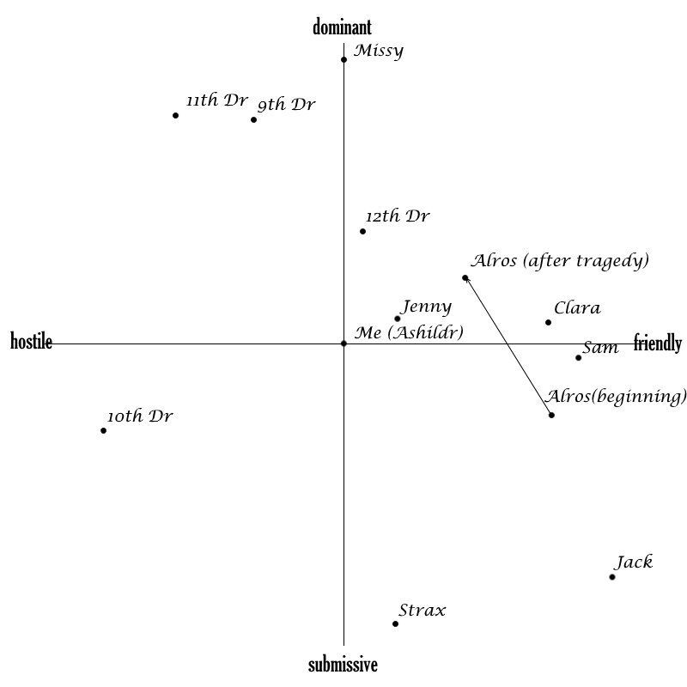
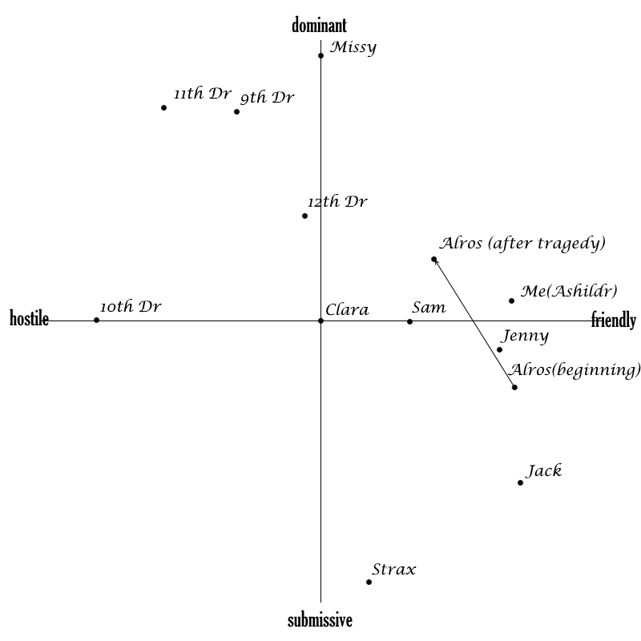

Main enemy Characters
9th Doctor’s clone | 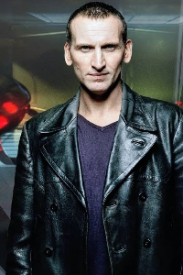 | The Brute leading the barracks in Waflorix.
10th Doctor’s clone | 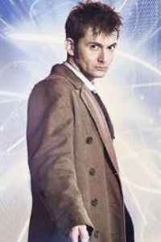 | The mad scientist that controls Steon A61.
11th Doctor’s clone | 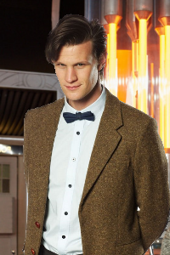 | The manipulative Boss of the Kobroth’s mine.
12th Doctor’s clone | 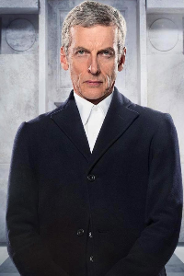 | The strong Leader guarding the capsules on Pledatite.
Missy, the Mastermind | 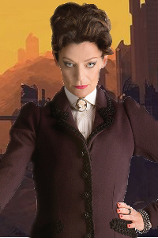 | Missy is a time Lord, with the Doctor they are the last of the specie. She has a friendship-hate relationship with the Doctor, as she states that they both need to try to kill each other, without really succeeding because of their strong bond. Manipulative and crazy, she has moments of pure madness alternate to pure genius. She seeks strong revenge towards the people she felt like her, but that strongly tries to estrange her.

Races:
Cyberman | 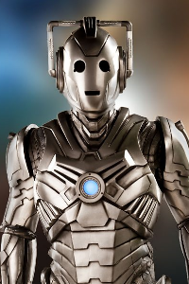 | A race of cybernetically augmented humanoids.  In combat they are stronger in the cleric class: they deal damage and they are capable of repairing themselves to heal their health back.
Ice Warrior | 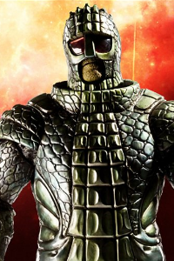 | A race of reptilian humanoids from the planet Mars.  In combat they are stronger in the mage class: they use their abilities to deal damage to groups of enemies and to slow and stun them.
Silurian | 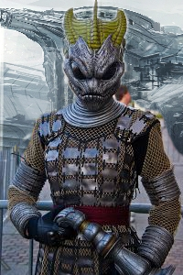 | A reptilian race native to Earth that pre-dated humanity.  In combat they are stronger in the thief class: their high agility allows them to access the enemies all over the battle zone, dealing high burst of damages.
Sontaran | 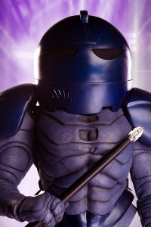 | A race of belligerent and militaristic clones from Sontar.  In combat they are stronger in the warrior class: thanks to their heavy armour and strong constitution they can tank high damage while losing little health.

Every race has a type of fighter for each different class, but every race is much stronger in the class they are the most similar to (ie. there are warrior, mage, cleric and thief silurians, but the thief is much stronger than the others).

Enemies encountered in the level:
Cyberman
Cyber-Fighter | Cyberman with higher value of Strength
Cyber-Sorcerer | Cyberman with higher value of Intelligence
Cyber-Thief | Cyberman with higher value of Dexterity
Cyber-Leader (Cleric) | Cyberman with higher value of Wisdom and Constitution
Sontaran
Sontaran Wizard | Sontaran with higher value of Intelligence
Sontaran Leader (Warrior) | Sontaran with higher value of Strength and Constitution
Wild animals
Rabid dog | Wild dog infected with rabies that increases its Strength
Pack dog | Wild dog leader of its pack, with increased Dexterity and Constitution
Rabid bear | Wild bear infected with rabies that increases its Strength

